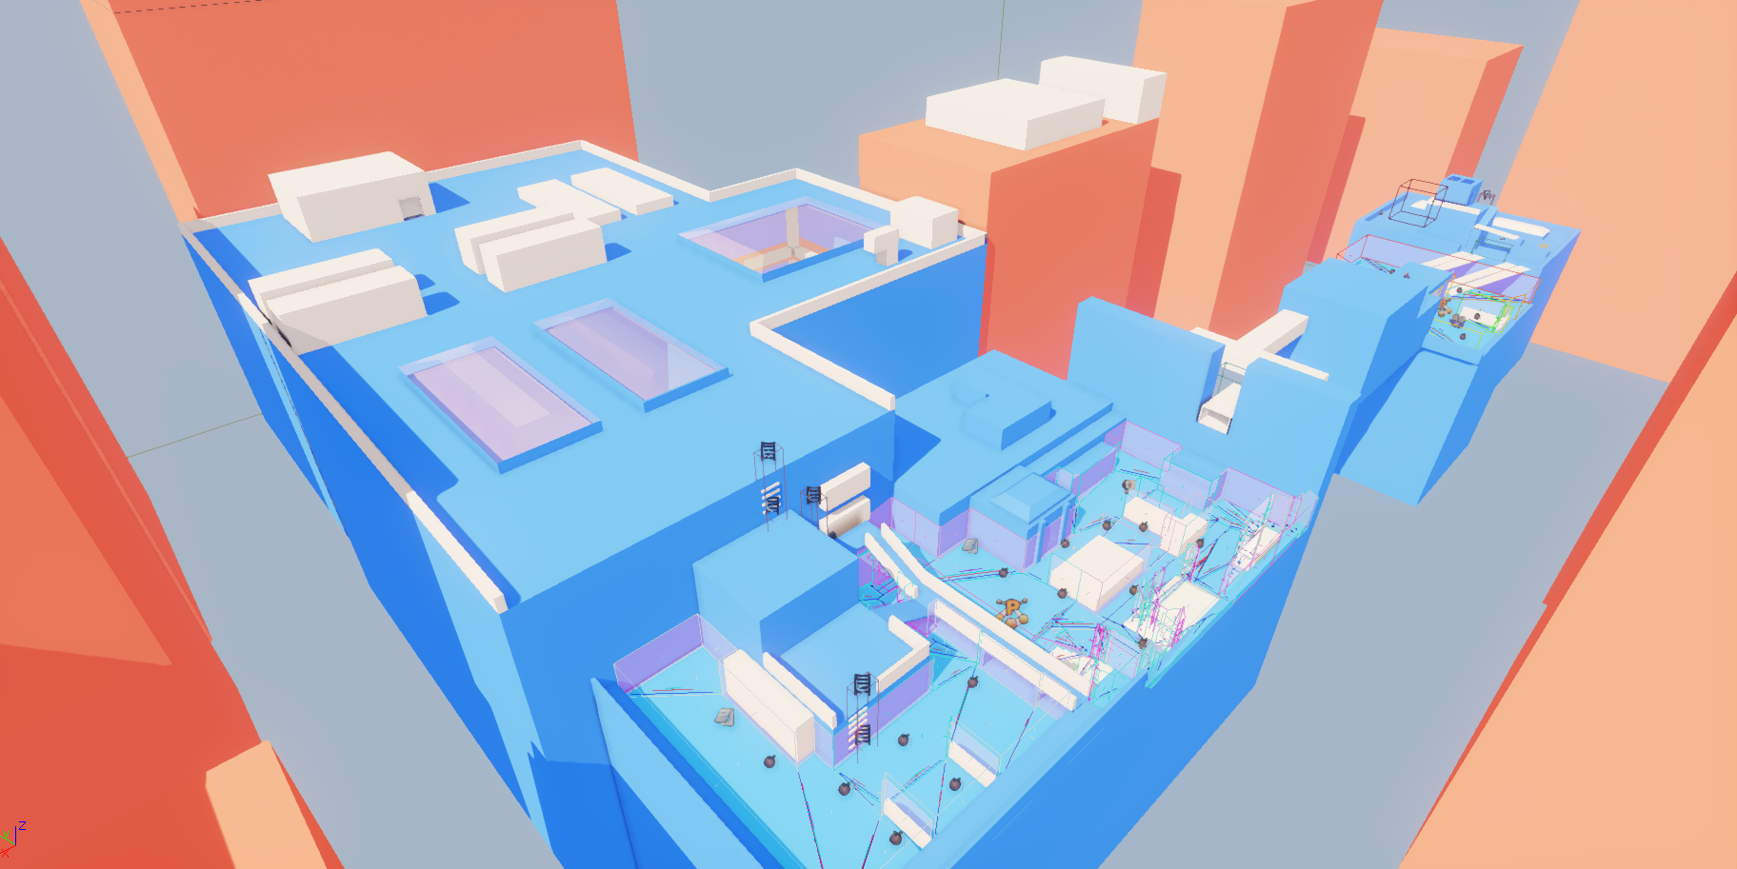
Rooftops block-out level breakdown

Breakdown of level explaining area 1 and 2 with scripts and direction.

Player Weapon pick up
Area 1
Player starting point
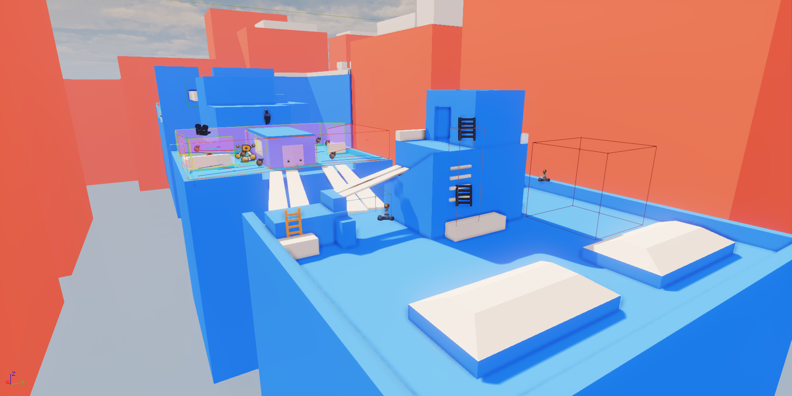

Checkpoint

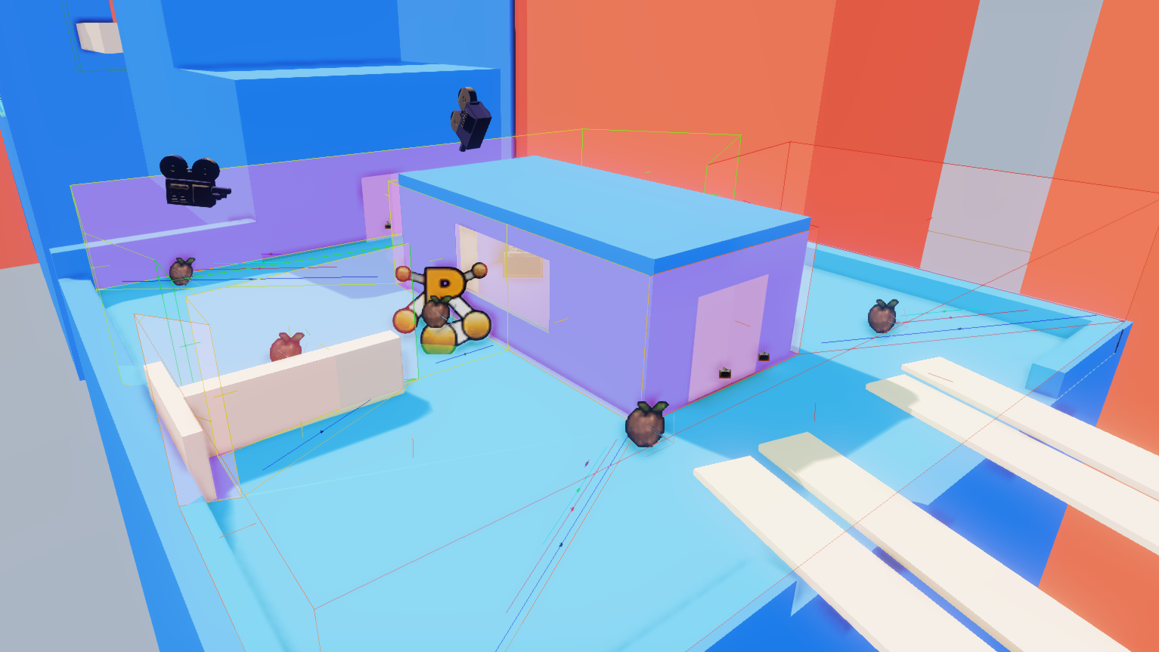

The main objective for this level, - basing on an action set up is to search the rooftops for information and decrypt 3 computers within the area.
The first one is provided within the center of the map.

Hazards: during this part of the level are, a patrolling guard and a security camera, (on when detected resets the player to a previous checkpoint).

The guard is carrying a key, which unlocks main next area doors when defeated, which has to be completed to progress.

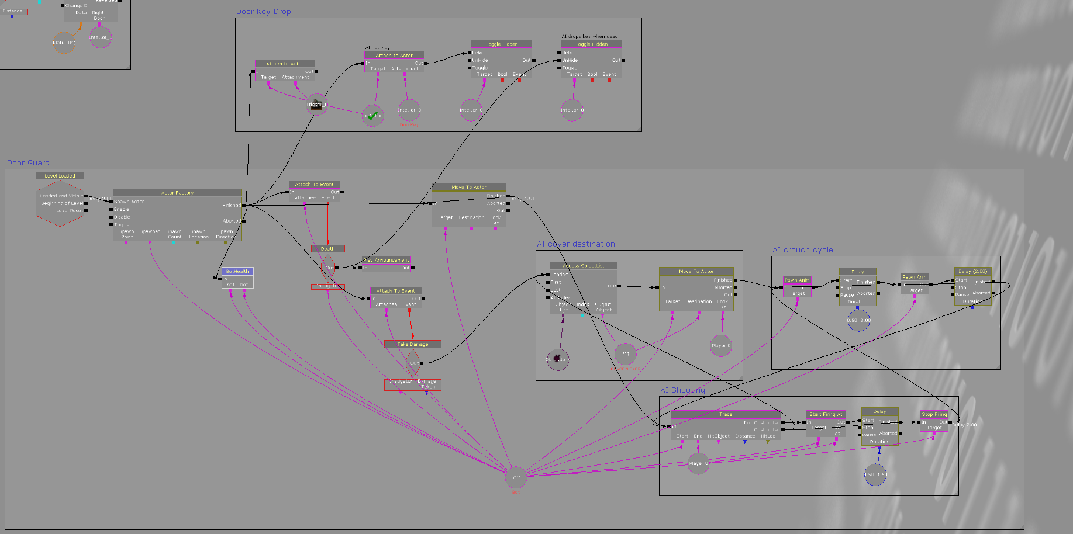
Kismet Guard script breakdown

Example for script used for the guard carrying the key objective. The guard simple spawns after a 2 second delay when the player starts the level. The guard starts patrolling. I have used a loop destination for main patrol. When the guard spot the player and takes damage it chooses a random cover point location I have assigned, which then attempts to take down player on command. The script is also set up, on when the bot cannot see the player he moves to a better random location point. After a certain amount of time on not spotting the player he returns to his patrol route.

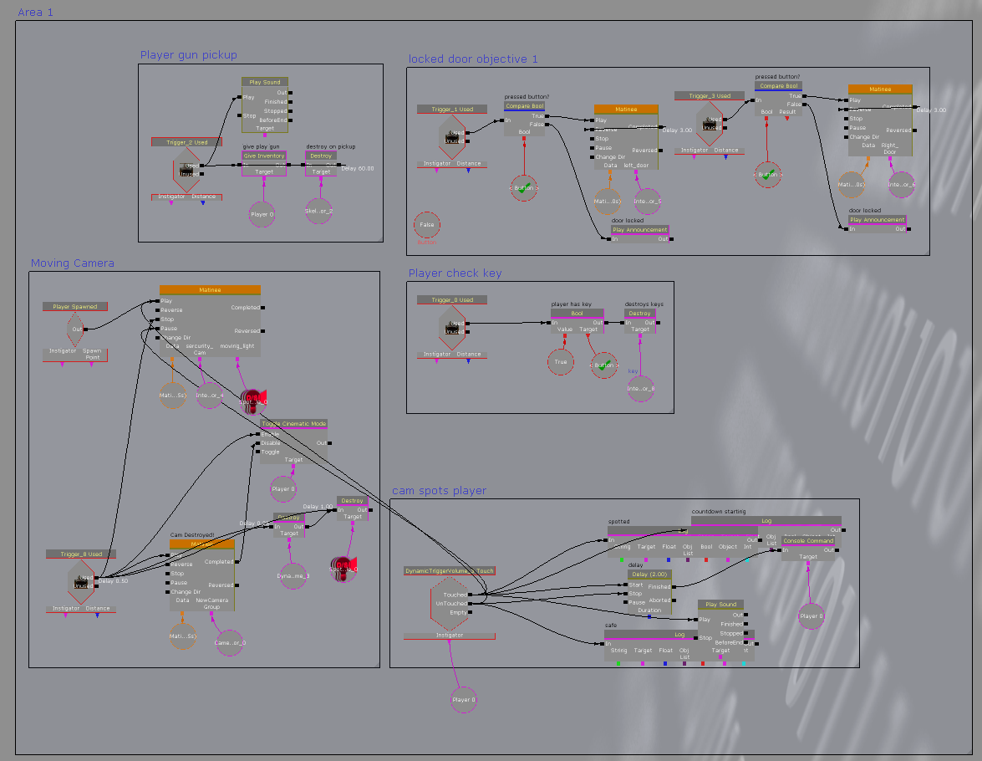
Area 1 overview explaining camera hazard on a player check and objectives.

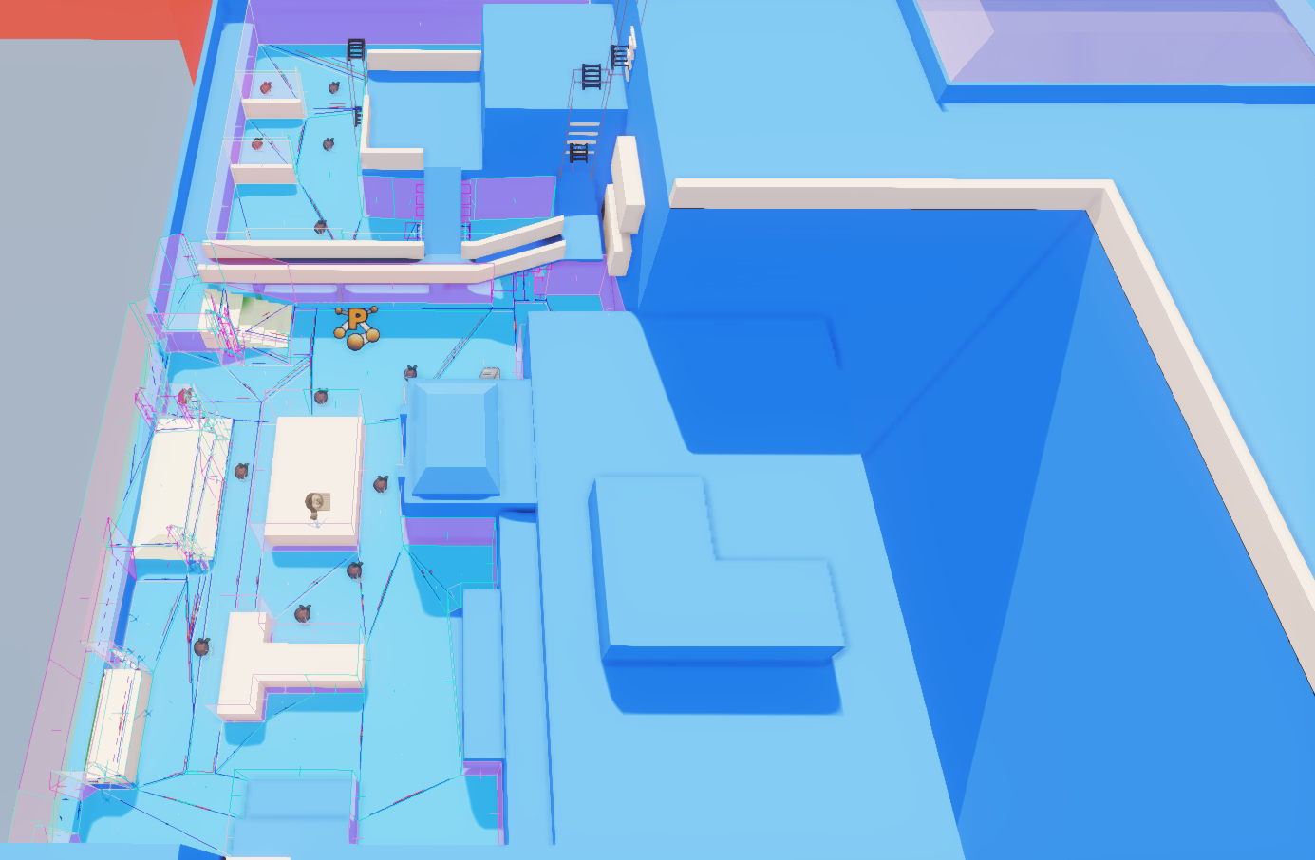
Area 2
The setup for this area:, when the player climbs through a air-duct preparing the next action sequence. When the player enters this area, 3 bots appear. 1 close up that dives straight for cover, and 2 sniper type bots at the back end of the level, which don’t progress forward [unlike the first bot that appears at the start].

Kismet breakdown
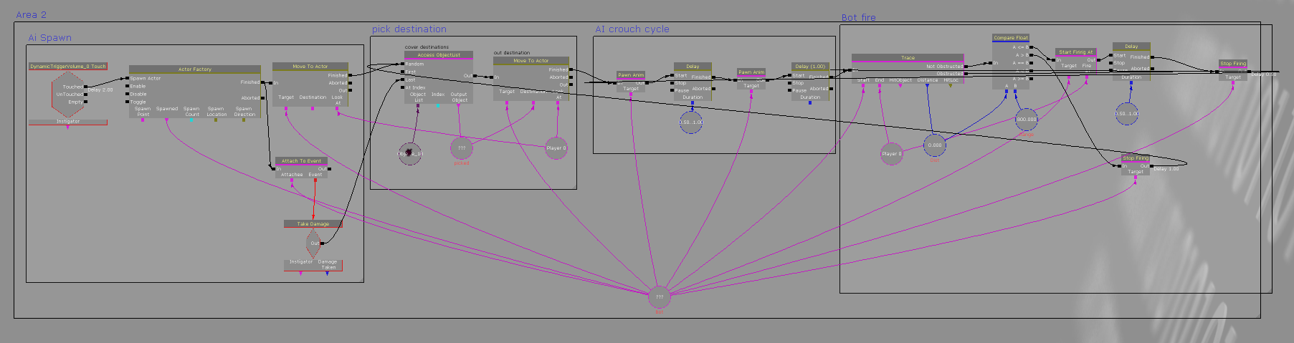
Whilst using the same random paths that the bot will choose. I have decided to increase the level of difficulty buy adding a distance trace on how far the bot can see the player. With a higher distance it will make it harder for the player to progress to get to the next 2 computer objectives.

